
REPUBLIC OF CAMEROON
PEACE-WORK-FATHERLAND
UNIVERSITY OF BUEA
FACULTY OF ENGINEERING AND TECHNOLOGY

DEPARTMENT OF COMPUTER ENGINEERING

CEF 440: INTERNET PROGRAMMING AND MOBILE PROGRAMMING

TASK 7: FINAL PROJECT REPORT

COURSE INSTRUCTOR: Dr Nkemeni Valery

PRESENTED BY GROUP 8:

SALLE YIMNAI BRYAN NZUME ETUGE: FE23A140
MANIKEU TINKEU MARIE ANGE PRINCESSE: FE23A086
FONGANG FAITH ACHO: FE23A059
ANDIGEMA JOYCE ANI: FE23A012
NDIP SAMUEL AGBOR OJONG: FE23A101
Table of Contents
1. Introduction 1
1.1 Project Overview 1
1.2 Objective of This Report 1
1.3 Problem Statement 1
1.4 Aim and Objectives 2
1.5 Scope and Delimitations 3
1.6 Summary of the Preceding Tasks 3
2. Background and Related Work 3
2.1 Types of Mobile Applications 4
2.2 Mobile Architectures and Design Patterns 4
2.3 On-Device Machine Learning 4
2.4 Dashboard Warning Lights and Engine Sounds 5
2.5 Related Works 5
2.5.1 OBD-II Scanner Applications 5
2.5.2 Warning-Light Guide Applications 6
2.5.3 Engine-Sound Diagnostic Tools 6
2.5.4 General Sound-Classification Technology 6
2.6 Gap Addressed 6
3. Requirement Engineering 7
3.1 Stakeholder Identification 7
3.2 Requirement Gathering Techniques 7
3.3 Data Gathering and Key Findings 7
3.4 User Reluctance Assessment 8
3.5 Functional Requirements 8
3.6 Non-Functional Requirements 9
3.7 Completeness, Ambiguity and Feasibility Analysis 9
3.8 Requirements Prioritisation 10
4. System Design 10
4.1 Global Architecture 10
4.2 Context Diagram 11
4.3 Data-Flow Diagram 12
4.4 Use Case Model 12
4.5 Sequence Design 13
4.6 Class Design 13
4.7 Deployment Design 14
4.8 Database Design 14
4.9 User-Interface Design 15
4.9.1 App Identity 15
4.9.2 Visual Design System 16
4.9.3 Screen Inventory 16
5. Implementation 17
5.1 Tools and Technologies 17
5.2 Project Structure 18
5.3 Frontend Implementation 18
5.4 Database Implementation 18
5.5 Backend Implementation 19
5.6 Connecting the App to the Backend 19
5.7 On-Device Warning-Light Model 20
5.7.1 Synthetic Data Generation 20
5.7.2 Transfer Learning 20
5.7.3 Export, Quantisation and Integration 21
5.8 Engine-Sound Pathway 21
5.9 Build and Run 21
6. Results and Evaluation 21
6.1 The Running Application 21
6.2 Warning-Light Model Accuracy 24
6.3 Backend and Database Verification 26
6.4 Response Times and Performance 26
6.5 Evaluation Against Requirements 27
6.6 Limitations 27
7. Challenges and Key Design Decisions 27
7.1 Communicating uncertainty responsibly 27
7.2 Safety interruptions that are actually read 28
7.3 A frontend that does not have to be rewritten 28
7.4 Practical development constraints 28
8. Conclusion and Future Work 28
8.1 Summary 28
8.2 Contribution 28
8.3 Future Work 29
References 29

1. Introduction

1.1 Project Overview
This report presents the final deliverable (Task 7) of the CarDiag project developed for CEF 440 (Internet Programming and Mobile Programming). CarDiag is an AI-based Android application that turns an ordinary smartphone into a first-level car fault diagnostic assistant. It recognises dashboard warning lights from the phone camera, records and analyses engine sounds, and returns plain-language explanations, an urgency level, tiered repair suggestions and safe next-step guidance - all working fully offline and without any external hardware.
The vehicles that circulate on Cameroonian roads are predominantly used imports, many of them older Japanese and European models whose electronic and mechanical systems are well past their first decade of service. Every one of these vehicles communicates its state of health to the driver through two primary channels: the dashboard instrument cluster, on which standardised warning lights illuminate when a subsystem reports a fault, and the characteristic sounds the engine and drivetrain produce as they operate. The problem CarDiag addresses is that the ordinary driver can rarely interpret either channel, and therefore cannot judge whether a symptom is trivial or dangerous.
This report consolidates the work of the six preceding tasks - the mobile development process (Task 1), requirement gathering (Task 2), requirement analysis and the Software Requirements Specification (Task 3), system modelling and design (Task 4), user-interface design and frontend implementation (Task 5), and database and backend implementation (Task 6) - into a single account of the completed system, and it documents in full the on-device machine-learning models that provide the application's diagnostic intelligence and that were built after Task 6.

1.2 Objective of This Report
The objective of this report is to present the finished CarDiag application end to end: the problem it solves, the requirements it was built against, its design and architecture, how it was implemented (including the machine-learning pipeline), the results obtained, and an evaluation of the solution against its requirements. Where earlier tasks are summarised, the emphasis is placed on the completed, working system and on the machine-learning component that was not part of Tasks 1–6.

1.3 Problem Statement
Non-technical car owners routinely encounter dashboard warning lights and unusual engine sounds that they cannot interpret, and many consequently ignore them, allowing minor faults to escalate into costly repairs or unsafe breakdowns. This is acute in the Cameroonian context of predominantly older imported vehicles, intermittent and costly connectivity, and the expense of professional diagnosis or dedicated On-Board Diagnostics (OBD-II) hardware. The problem was not assumed; it was measured. During requirement gathering (Task 2) the team surveyed 54 car owners and drivers and interviewed 7 professional mechanics, auto-electricians and vehicle technicians. The findings quantify the problem clearly:
- 83.3% of surveyed drivers had seen a dashboard warning light they did not understand.
- 66.7% had ignored a warning light specifically because they did not understand it - the single largest behavioural risk identified in the study.
- 85.2% had heard an unusual engine sound they could not identify.
- 70.4% expressed willingness to use a smartphone application to scan warning lights, and 75.9% to use an engine-sound diagnosis feature.
- 70.4% preferred that basic diagnosis work offline, reflecting the unreliable and costly connectivity in parts of the country.
- 77.8% said they would still confirm any result with a professional mechanic - evidence that drivers want assistance, not a replacement.
Existing solutions do not close this gap for the target user. OBD-II scanner applications require the purchase of an external adapter and return raw diagnostic trouble codes that are themselves unintelligible to a layperson. Static warning-light guides require the user to already know the symbol in order to look it up. Professional diagnosis is accurate but requires time, travel and money at precisely the moment the driver is most uncertain about whether the vehicle is even safe to drive. The problem, therefore, is not a shortage of automotive knowledge in the world; it is the absence of that knowledge in the driver's hand, in a form the driver can use immediately, offline, and without specialised equipment.

1.4 Aim and Objectives
The aim of this project is to design, implement and evaluate an AI-based mobile application that enables non-technical car owners to perform preliminary fault diagnosis using only a smartphone. This aim was pursued through the following specific objectives:
- To gather and analyse the real needs, concerns and constraints of the target users and domain experts, and to formalise them into a validated software requirements specification.
- To model and design an offline-first, privacy-preserving, safe and usable system architecture, data model and user interface.
- To implement a native Android application that realises the design with a modern, maintainable architecture and a bundled knowledge base so that all core features work offline.
- To design and implement the data layer - an on-device database, an online catalogue and a synchronisation mechanism - while ensuring that private user data never leaves the device.
- To develop and integrate an on-device machine-learning model that recognises dashboard warning-light symbols from the phone camera, and to establish the audio-analysis pathway for engine-sound diagnosis.
- To evaluate the resulting system against its stated requirements and to assess the accuracy of the diagnostic models.

1.5 Scope and Delimitations
The delivered system (Version 1) covers camera-based recognition of common dashboard warning lights, a fully offline searchable dictionary, engine-sound recording and classification, a guided symptom-input pathway, four-level urgency classification, plain-language explanations, three-tier repair suggestions and preventive tips, confidence scoring, a mandatory safety and mechanic-referral layer, a saved-vehicle garage, a local diagnosis history, saved emergency contacts, and an online catalogue with delta synchronisation. The application targets Android 8.0 (API 26) and above and performs all diagnostic inference on the device.
Certain capabilities were deliberately placed outside the boundary of Version 1 on the basis of the feasibility analysis: OBD-II hardware integration (which contradicts the smartphone-only principle), simultaneous multiple-warning-light detection (which requires an object-detection model and an annotated dataset), a live GPS-based mechanic directory (whose data-collection burden is disproportionate to the project timeline), and iOS support and a French-language interface (deferred to later versions). These delimitations are documented, justified and mapped to future versions rather than silently omitted.

1.6 Summary of the Preceding Tasks
The table below situates this report within the sequence of tasks it consolidates.
Task | Focus | Principal outcome
Task 1 | Mobile development process | Study of app types, languages, frameworks, architectures and cost estimation.
Task 2 | Requirement gathering | Survey (54 users), 7 expert interviews, reverse engineering of 5 apps.
Task 3 | Requirement analysis | 22 functional + 11 non-functional requirements; SRS v1.1; MoSCoW prioritisation.
Task 4 | System modelling and design | Context, DFD, use-case, sequence, class and deployment diagrams.
Task 5 | UI design and frontend | App identity, design system, 16 Compose screens (MVVM).
Task 6 | Database and backend | Room (SQLite) on-device DB, Firestore catalogue, Node/Express + Retrofit sync.
Task 7 | Final report (this document) | Consolidated system + on-device ML models + results and evaluation.

2. Background and Related Work
This section establishes the conceptual and technological foundation on which CarDiag is built and positions the project against existing work. It reviews the kinds of mobile application and the architectures that structure them, the on-device machine-learning technologies that make offline diagnosis possible, and the automotive standards and signals the application interprets, before surveying related tools and identifying the specific gap this project fills.

2.1 Types of Mobile Applications
Mobile applications are commonly classified by how they are built and how they access the device. Native applications are developed for a single platform using its official tools - Kotlin or Java with the Android SDK, Swift or Objective-C with the iOS SDK - and obtain the fullest and fastest access to device hardware such as the camera, microphone and on-chip accelerators, at the cost of maintaining separate codebases per platform. Web applications run inside the browser using HTML, CSS and JavaScript; they are cheap and platform-independent but have restricted access to device sensors and depend on connectivity. Hybrid applications wrap web content in a native shell (for example through Apache Cordova or Ionic), reusing web code while gaining some device access through plugins. Cross-platform frameworks such as Flutter (Dart) and React Native (JavaScript) compile a single codebase to near-native components on both platforms.
Because CarDiag depends critically on low-latency, offline access to the camera, the microphone and an on-device machine-learning runtime, the native Android approach was selected. The trade-off - a single-platform Version 1 - is accepted deliberately, and iOS is deferred to a later version that can reuse the same design.

2.2 Mobile Architectures and Design Patterns
A maintainable mobile application separates its user interface from its business logic and its data. The Model–View–Controller (MVC) pattern was the historical norm but tends to concentrate too much responsibility in the controller. The Model–View–ViewModel (MVVM) pattern, recommended by Google for modern Android, interposes a ViewModel that exposes observable state to the View while holding no reference back to it, which improves testability and decouples the interface from the data sources. Clean Architecture generalises this into concentric layers in which inner layers (domain logic) never depend on outer layers (frameworks, user interface), so that the interface or the storage mechanism can change without disturbing the core.
Alongside these architectural patterns, several classical design patterns recur in mobile development: the Singleton pattern for shared resources such as a database connection; the Observer pattern for propagating state changes to the interface; and Dependency Injection for supplying a class's collaborators from outside, which improves testability. CarDiag adopts MVVM with a light clean-architecture separation and uses observable state and interface-based dependency provision. This choice is what later allowed the database, backend and machine-learning models to be attached behind stable interfaces without rewriting any screen.

2.3 On-Device Machine Learning
The diagnostic intelligence of CarDiag rests on running compact neural networks directly on the phone. TensorFlow Lite (now LiteRT) is Google's runtime for this purpose: a model trained with TensorFlow is converted into a small, self-contained flatbuffer (a .tflite file) that executes on the device's CPU, or on the GPU through a delegate when available. Two techniques make such models small enough to bundle in an application.
Transfer learning starts from a network already trained on a very large dataset and retrains only its upper layers on the task at hand, achieving high accuracy from a modest amount of task data. CarDiag uses MobileNetV2, a lightweight convolutional architecture designed for mobile that uses inverted residual blocks and depthwise-separable convolutions to minimise computation; its ImageNet-pretrained weights provide a strong general visual feature extractor. Quantisation then compresses the trained model by reducing the numeric precision of its weights, typically shrinking it several-fold and accelerating inference with little accuracy loss.
For audio, the standard approach converts a recording into a compact spectral representation - Mel-Frequency Cepstral Coefficients (MFCCs) or a mel-spectrogram - that captures the timbral signature of a sound, and classifies those features. Google's YAMNet is a widely used pre-trained audio event classifier built on this principle. CarDiag uses MobileNetV2 transfer learning with quantisation for warning-light recognition and combines the pre-trained YAMNet model with a digital-signal-processing pathway for engine sound.

2.4 Dashboard Warning Lights and Engine Sounds
The symbols CarDiag recognises are governed by ISO 2575, the international standard for road-vehicle symbols for controls, indicators and tell-tales, which most manufacturers follow. The standard implies a colour convention that carries urgency: red tell-tales generally demand that the driver stop or act immediately (for example oil pressure, brake system, engine temperature), amber or yellow tell-tales indicate a fault that should be checked soon (for example the check-engine or ABS lights), and green or blue tell-tales are informational. This colour–urgency relationship is exploited directly in CarDiag, both as a fallback pathway when a symbol cannot be identified by shape and as the default rule for assigning an urgency level.
On the audio side, mechanics categorise abnormal engine sounds into a small vocabulary - knocking, squealing, hissing, rattling, grinding - each statistically associated with particular fault families. Knocking may indicate ignition timing or bearing problems; squealing often indicates a worn accessory belt; hissing may indicate a vacuum or coolant leak. This vocabulary forms the label set for the engine-sound pathway.

2.5 Related Works
Four categories of existing solution were reviewed during requirement gathering, each of which informs CarDiag by its strengths and its limitations for the non-technical, offline, hardware-free user.

2.5.1 OBD-II Scanner Applications
Applications such as Car Scanner ELM OBD2, OBD Auto Doctor and OBDeleven read fault information directly from the vehicle's engine control unit through an OBD-II port. Their contribution is authoritative, standardised data: genuine diagnostic trouble codes, live sensor streams, vehicle profiles and diagnostic histories. Their limitation for this project's audience is twofold: they require the purchase and installation of an external Bluetooth or Wi-Fi OBD-II adapter, a hardware cost and technical step many owners will not take; and the trouble codes they surface are meaningful to technicians but opaque to laypeople. CarDiag borrows their good practices - clear presentation of results, a saved vehicle profile, a diagnosis history - while removing the hardware dependency and translating findings into plain language.

2.5.2 Warning-Light Guide Applications
A second category comprises static reference guides that organise warning lights by symbol, colour, meaning and severity. Their contribution is exactly the curated, plain-language explanatory content a good diagnostic result needs, and CarDiag's offline knowledge base is directly inspired by them. Their central limitation is the lookup problem: to find a symbol in a list, the user must already be able to name or classify it - which is the very difficulty they set out to solve. CarDiag addresses this by adding camera-based recognition and colour triage on top of a searchable dictionary.

2.5.3 Engine-Sound Diagnostic Tools
Tools such as the ŠKODA Auto Sound Analyzer demonstrate that audio-based fault classification on consumer hardware is feasible: a recorded sound can be matched against known fault signatures to suggest likely causes. Their contribution is the proof of concept and the emphasis on recording quality; their limitation is sensitivity to background noise and the risk of over-stating certainty on an inherently ambiguous signal. These lessons are encoded in CarDiag as a mandatory recording-safety and ambient-noise gate, explicit confidence scoring, guided follow-up questions, and a firm rule that a low-confidence result never names a specific fault.

2.5.4 General Sound-Classification Technology
Beyond automotive-specific tools, the broader field of environmental sound classification - exemplified by models such as YAMNet trained on large audio-event datasets - provides the underlying technology for the engine-sound pathway. Its contribution is a ready, pre-trained feature extractor and classifier that runs on-device; its limitation is that its label vocabulary is general rather than automotive, which is why CarDiag pairs it with a domain-specific signal analysis and, as future work, a custom-trained engine-fault classifier.

2.6 Gap Addressed
The reviewed literature and tools show that the individual building blocks CarDiag needs are mature: native Android gives full sensor access, MVVM and on-device TensorFlow Lite make offline intelligence practical, ISO 2575 and the mechanics' sound vocabulary provide well-defined label sets, and existing applications supply proven interaction patterns and curated content. What none of the existing solutions provides for the target user is the combination of all of these: recognition of an unknown warning light from a photograph and of an engine sound from a recording, delivered in plain language with explicit urgency and honesty about uncertainty, working entirely offline and without any external hardware. That specific, unfilled combination is the gap this project addresses.

3. Requirement Engineering
This section summarises the requirement-engineering work of Tasks 2 and 3: the stakeholders, the elicitation techniques and their findings, the classified functional and non-functional requirements, the analysis of gaps and feasibility, and the prioritisation that defined Version 1.

3.1 Stakeholder Identification
Stakeholders were grouped into primary and secondary. The primary stakeholders are car owners and drivers - the main end users, most likely to encounter warning lights and sounds they cannot interpret - together with mechanics, auto-electricians and vehicle technicians, whose expertise validates whether the application's suggestions are realistic and safe. Secondary stakeholders include car-maintenance content providers whose tutorials may support the guidance feature. The internet and mobile-data environment is treated as an external dependency rather than a human stakeholder, since some features rely on connectivity that is neither universal nor cheap in the local context.

3.2 Requirement Gathering Techniques
Requirements were elicited using four complementary techniques:
- Questionnaire. A Google Forms survey, limited to one response per user with all but the final question compulsory, gathered the experiences, challenges, feature preferences and trust concerns of 54 car owners and drivers across two collection phases.
- Interviews. Structured interviews with 7 mechanics, auto-electricians and vehicle technicians supplied domain expertise on fault classification, urgency criteria, safe advice and the limits of phone-based diagnosis.
- Brainstorming. Team sessions converted the raw findings into candidate features and separated those realistic for a first version from those to be deferred.
- Reverse engineering. Five existing applications (OBD, guide and sound-analysis tools) were studied to identify proven patterns, workflows and gaps the proposed solution could address.

3.3 Data Gathering and Key Findings
The combined dataset comprised 54 questionnaire respondents, 7 expert interviews and 5 reviewed applications. The table below records the key user statistics that shaped the requirements.
Metric | Result (n = 54)
Have seen an unknown dashboard warning light | 83.3%
Have ignored a warning light due to not understanding it | 66.7%
Have heard an unusual engine sound they could not identify | 85.2%
Would use a warning-light scanning application | 70.4%
Would use an engine-sound diagnosis application | 75.9%
Prefer offline basic diagnosis | 70.4%
Want expert video-tutorial links | 83.3%
Would still confirm the diagnosis with a mechanic | 77.8%

3.4 User Reluctance Assessment
The elicitation deliberately assessed reluctance as well as need. Cooperation was moderate - 29 initial and later 25 further questionnaire responses, and 7 of a larger number of approached experts - and the reluctance itself was informative. Some mechanics were wary that an automated tool might reduce customer visits or replace their expertise. This surfaced the project's defining constraint: CarDiag must present itself as “an assistant, not a replacement.” That single principle shaped the requirements for confidence scoring, mandatory safety disclaimers and mechanic-referral prompts, and ultimately the entire visual identity.

3.5 Functional Requirements
Twenty-two functional requirements (FR01–FR22) were extracted, described, sourced and categorised. They are listed in full below.
ID | Functional requirement
FR01 | Camera-based warning-light scanning using an on-device computer-vision model.
FR02 | Manual, fully offline searchable dictionary of warning-light symbols.
FR03 | Detection of more than one active warning light from a single capture (deferred).
FR04 | Warning-light explanation: name, description, possible causes, urgency, first action.
FR05 | Engine-sound recording via the microphone, behind a safety-instruction screen.
FR06 | Audio fault classification into categories (knocking, squealing, hissing, etc.).
FR07 | Up to five guided follow-up questions to refine a sound assessment.
FR08 | Four-level urgency classification: Low, Medium, High, Critical (colour-coded).
FR09 | Repair suggestions split into safe-to-do and needs-a-mechanic, with preventive tips.
FR10 | Curated expert video-tutorial links matched to the fault (online only).
FR11 | Offline basic functionality - core features work with no internet access.
FR12 | Online fault-database synchronisation when connected.
FR13 | Non-removable safety disclaimer on every result screen.
FR14 | Mechanic-referral prompt; non-dismissible for High/Critical results (FR14a: call).
FR15 | Vehicle profile (make, model, year, fuel, engine generation) for vehicle-specific results.
FR16 | Local diagnosis history with date, type, fault, urgency and a user note.
FR17 | Confidence indicator on all ML results; low confidence suppresses the fault name.
FR18 | Mandatory recording-safety instruction screen before any audio session.
FR19 | General preventive-maintenance tips per fault category.
FR20 | Optional local mechanic directory with contact information (deferred).
FR21 | Manual warning-light fallback when camera scanning is low-confidence/unrecognised.
FR22 | Guided symptom-input questionnaire producing a preliminary assessment.

3.6 Non-Functional Requirements
Eleven non-functional requirements (NFR01–NFR11) define the quality attributes and constraints the system must satisfy.
ID | Non-functional requirement
NFR01 | Usability: plain language and icons; any core task ≤ 3 taps from the home screen.
NFR02 | Offline availability: all core features function from first launch with no connection.
NFR03 | ML accuracy: image classifier ≥ 85% top-1; audio classifier ≥ 75% top-1.
NFR04 | Response time: camera scan ≤ 3 s; audio ≤ 10 s; search ≤ 500 ms per keystroke.
NFR05 | Privacy: on-device inference only; raw images/audio never stored or transmitted.
NFR06 | Multi-language support (English v1; French deferred to v2).
NFR07 | Compatibility: Android 8.0+ / iOS 13+; ≥ 2 GB RAM, 100 MB free storage.
NFR08 | Data security: encrypted local storage; a “delete all my data” option.
NFR09 | Scalability: schema supports growth and delta updates via revision columns.
NFR10 | Reliability: crash-free session rate ≥ 98% over a 30-day monitoring period.
NFR11 | Accessibility: WCAG 2.1 AA contrast; urgency never conveyed by colour alone.

3.7 Completeness, Ambiguity and Feasibility Analysis
The analysis identified eight completeness gaps (GAP-01 to GAP-08), each resolved with a documented decision. These included defining the ML accuracy thresholds (NFR03), specifying the platform (Android primary), formalising a privacy and consent policy, and - from the second questionnaire batch - adding an engine-generation field to support modern Japanese engine variants common as used imports (GAP-08). Six ambiguities and five inconsistencies were likewise resolved: the terminology was standardised on “preliminary assessment” rather than “diagnosis”; a four-level urgency scale was adopted over a competing three-level proposal; and audio classification was retained but paired with mandatory confidence scoring so that an uncertain result never names a specific fault.
A technical-feasibility assessment rated camera-based recognition and offline inference as highly feasible (mature computer-vision and TensorFlow Lite technology), audio classification and multiple-light detection as moderately feasible (noise sensitivity and dataset complexity respectively), and a live mechanic directory and OBD-II integration as low feasibility, leading to their deferral. This assessment directly informed the prioritisation below.

3.8 Requirements Prioritisation
Requirements were prioritised with the MoSCoW method. The Must-Have core that defines Version 1 comprises camera scanning and the offline dictionary resolving to plain-language explanations (FR01, FR02, FR04), four-level urgency (FR08), confidence scoring (FR17), the mandatory safety disclaimer and mechanic referral (FR13, FR14), and full offline operation (FR11). The engine-sound pathway (FR05–FR07), repair suggestions (FR09) and the manual fallback (FR21) are Should-Haves. The vehicle garage (FR15), diagnosis history (FR16), online video links (FR10) and database sync (FR12) are Could-Haves. OBD-II integration, a live mechanic directory (FR20) and multiple-light detection (FR03) are deferred to future versions.

4. System Design
The design phase (Task 4) produced a complete set of models grounded in the baselined SRS. This section presents the global architecture and then each model in turn - context, data-flow, use-case, sequence, class and deployment - followed by the database and user-interface designs.

4.1 Global Architecture
CarDiag is structured as three cooperating subsystems layered over an MVVM core. The on-device AI subsystem hosts the TensorFlow Lite runtime and the two classifiers. The offline knowledge-base subsystem is a bundled database of fault content, available from first launch. The online content subsystem - the sync server or Firebase, plus the video registry - is strictly optional and enriches, but never gates, the core experience. Above these, the MVVM layers separate a framework-free domain model, a data layer exposed only through the CarDiagRepository and DiagnosisService interfaces, a single AppViewModel holding observable UI state and the navigation back-stack, and a Jetpack Compose View. All diagnosis runs on the device; the sync server and YouTube are external nodes reached, when at all, only over HTTPS.
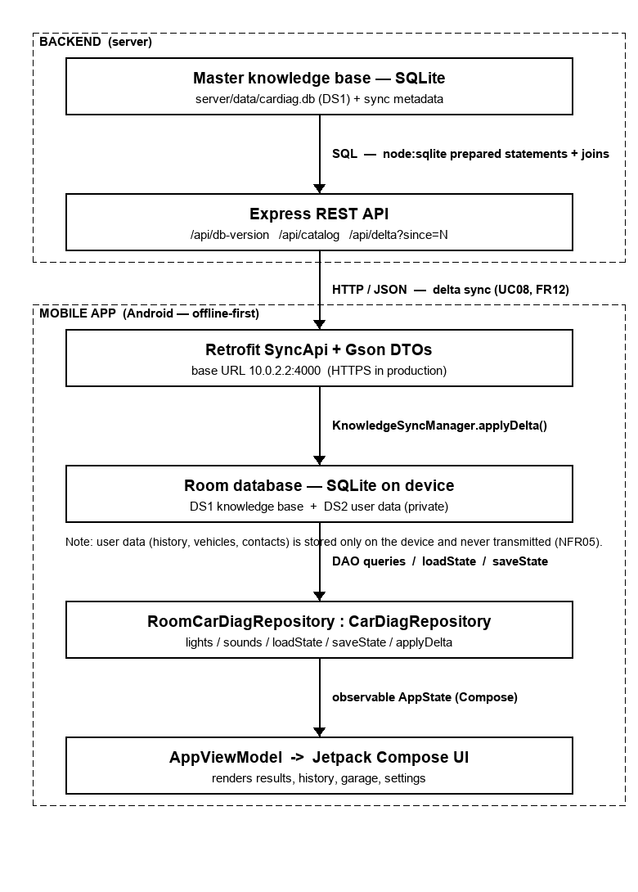
Figure 1: Global data flow: online store → REST/Firestore → on-device repository → UI, with the whole right-hand side operating offline from the bundled database.

4.2 Context Diagram
The context model fixes the system boundary and identifies four external actors. All sensor data flows from the car owner are processed entirely on-device; no raw image or audio ever crosses the boundary.
External actor | Role and interaction
Car owner (primary user) | Supplies camera images, audio recordings and symptom text; receives results, urgency, repair suggestions and safety guidance. The only real-time actor.
Sync server (online backend) | Sends delta update packages of fault records and video URLs in response to synchronisation requests. Optional; Version 2.
YouTube (video platform) | Hosts expert tutorial videos; the app opens curated URLs in the device browser (no direct API calls in v1).
Automotive expert (content source) | Mechanics whose domain knowledge populates the offline knowledge base; they interact indirectly via an admin tool, not in real time.

4.3 Data-Flow Diagram
The Level-0 data-flow model decomposes the system into four processes over three data stores. The processes are input capture (P1), on-device AI (P2), result generation (P3) and optional background data sync (P4). The data stores are the offline knowledge base (DS1), the private diagnosis history (DS2) and the video-URL registry (DS3).
Element | Description
P1 Input capture | Accepts a camera image, an audio recording (up to 30 s) or symptom text and passes it to P2.
P2 On-device AI | Runs the TFLite image or audio classifier, returns a category and confidence, and queries DS1 for the matching fault record.
P3 Result generation | Assembles the explanation, urgency, confidence, repair tiers, videos and disclaimer; writes a history entry to DS2.
P4 Data sync | Optional background service; polls the server version and applies delta updates to DS1 (Version 2).
DS1 Knowledge base | Bundled SQLite store of symbols, faults, causes, urgencies, repairs and videos. Read by P2/P3; available offline.
DS2 Diagnosis history | Encrypted local store of past sessions; written by P3; never transmitted.
DS3 Video URL registry | Curated map of fault categories to YouTube URLs; read-only from P3.

4.4 Use Case Model
Eleven use cases across three actors capture the system's behaviour. Two relationships formalise the safety and robustness design: UC01 includes UC07 for High/Critical results and extends to a manual-scan fallback (UC11) on low confidence.
ID | Use case | Brief description
UC01 | Scan a warning light | Capture a dashboard image and receive an explanation with urgency, confidence and suggestions.
UC02 | Search warning light manually | Browse or search the offline dictionary and select a symbol.
UC03 | Diagnose engine sound | Acknowledge the safety gate, record audio, answer follow-ups, receive an assessment.
UC04 | View repair suggestions | See three tiers of guidance, preventive tips and expert videos (online).
UC05 | Use app offline | Operate all core features with no internet connection.
UC06 | View diagnosis history | Review, note and delete past sessions (all local).
UC07 | Acknowledge safety prompt | Non-dismissible modal on High/Critical results with a timed acknowledgement.
UC08 | Sync fault database | Admin + server: apply a delta update to the local database (Version 2).
UC09 | Configure emergency contact | Save mechanic numbers offered in the Critical safety modal.
UC10 | View expert video | Open a curated YouTube link (online only).
UC11 | Manual scan fallback | Route to manual search when camera confidence is low.

4.5 Sequence Design
Each use case was elaborated as a UML sequence diagram detailing its lifelines and its alt/opt/loop fragments. The warning-light scan (UC01) includes a confidence-check fragment distinguishing the high-confidence path (full database lookup and result) from the low-confidence path (manual fallback), and an optional fragment for the safety modal. The engine-sound sequence (UC03) is the most complex, incorporating the timed safety gate, the ambient-noise check, the audio classification with feature extraction, and the follow-up questions. The safety-prompt sequence (UC07) distinguishes Critical from High urgency, adds emergency-contact call buttons for Critical faults, and enforces a minimum read delay before the acknowledgement button becomes active.

4.6 Class Design
The class model defines the object-oriented data model the implementation follows. Its principal classes and their responsibilities are:
Class | Responsibility
DiagnosticSession | Orchestrates the diagnostic pipeline from input to result; persists the session.
DiagnosticResult | Holds the urgency, confidence and fault category; retrieves the explanation and suggestions.
FaultRecord | A fault's description, causes, default urgency, engine-generation tag and vehicle applicability.
RepairSuggestion | A single repair instruction tagged by a SuggestionTier (NO_TOOLS / BASIC_TOOLS / WORKSHOP_ONLY).
VideoLink | A curated YouTube reference with title and duration for short-video prioritisation.
VehicleProfile | A saved vehicle used to filter results to vehicle-specific records.
HistoryEntry | A saved diagnosis session with a user-editable note; deletable from local storage.
ImageClassifier / AudioClassifier | The two on-device model abstractions producing a ClassificationResult.
ClassificationResult | A prediction with confidence and a below-threshold test that triggers the low-confidence path.
UrgencyLevel (enum) | LOW, MEDIUM, HIGH, CRITICAL - the value determines the modal type on a result.

4.7 Deployment Design
The deployment model places all core components on the mobile device (Android 8.0+, ≥ 2 GB RAM): the UI layer, the diagnostic engine, the TensorFlow Lite runtime hosting the two quantised models, the bundled SQLite knowledge base, and encrypted local storage for user data. The camera (via Camera2) and microphone (via AudioRecord) are hardware nodes accessed with permission. The sync server and YouTube are external nodes reached only over HTTPS; no raw sensor data is transmitted, and the app never communicates over plain HTTP.

4.8 Database Design
The data model was normalised to third normal form. Two parent entities represent the two automated pathways - warning_light (camera/manual) and engine_sound (audio) - each owning ordered child entities for its causes, tiered repair suggestions and curated videos, with engine_sound additionally owning its follow-up questions. Two lookup entities (urgency, repair_tier) provide controlled vocabularies. The private user data - vehicle, diagnosis_history and emergency_contact - is kept in a separate group stored only on the device. Repairs and videos, which may belong to either a light or a sound, are modelled with two nullable foreign keys and a CHECK constraint enforcing that exactly one owner is set. A rev (revision) column and a metadata version drive delta synchronisation. Privacy is enforced structurally: the server schema contains no user tables at all, so private data physically cannot be stored or transmitted there.
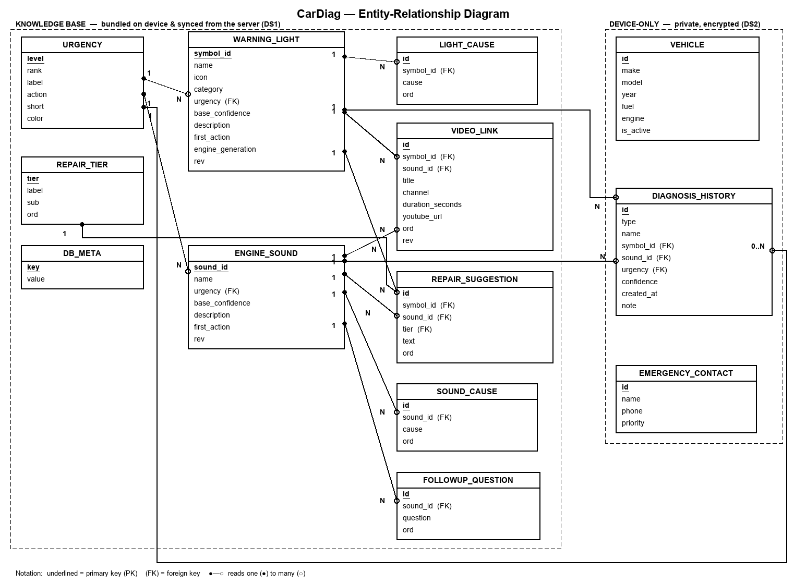
Figure 2: CarDiag entity-relationship diagram. The dashed groupings mark the privacy boundary: the knowledge base (bundled and synchronised) versus the device-only user data.
The data dictionary for the central warning_light entity is representative of the schema:
Attribute | Type | Key | Description
symbol_id | TEXT | PK | Stable identifier (e.g. 'oil', 'check').
name | TEXT |  | Display name (e.g. 'Oil Pressure').
category | TEXT |  | Engine / Brakes / Electrical / Tyres / Safety.
urgency | TEXT | FK | References urgency(level).
base_confidence | REAL |  | Default classifier confidence (0–1).
description | TEXT |  | Plain-language explanation.
first_action | TEXT |  | The single recommended first action.
engine_generation | TEXT |  | Optional engine tag (GAP-08).
rev | INTEGER |  | Revision for delta sync.

4.9 User-Interface Design

4.9.1 App Identity
The application is named CarDiag - a contraction of “Car Diagnosis” - chosen to be short, pronounceable and descriptive for a non-technical audience. Its logomark is a shield enclosing a pulse line: the shield communicates protection and trust, the pulse communicates the vehicle's vital signs and echoes the engine-sound waveform. The tagline “Your pocket diagnostic” and the splash line “Works fully offline” encode the two adoption-critical promises, while the deeper brand promise - “an assistant, not a replacement” - resolves the trust tension uncovered during requirement gathering. Two brand directions were prototyped: a cool, technical “Diagnostic Instrument” and a warm, reassuring “Trusted Companion.” The latter was selected because the evidence pointed to anxious, non-technical owners for whom a calm identity supports trust better than a clinical one.
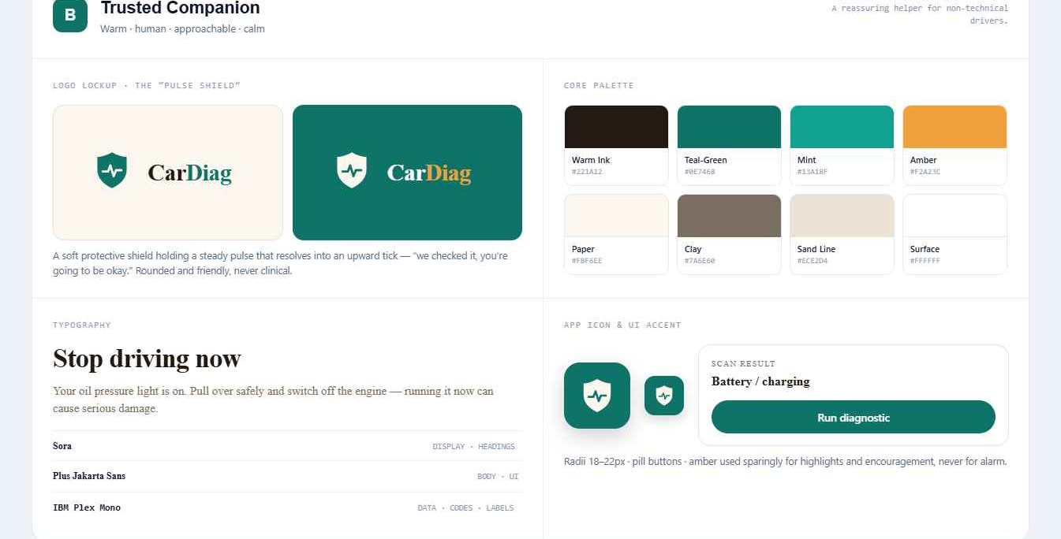
Figure 3: The selected “Trusted Companion” brand board - logomark, warm paper-and-green palette, typography and app icon.

4.9.2 Visual Design System
The interface is governed by a small token-based design system so that every screen is coherent and accessible by construction. The palette is warm and low-glare - a soft paper background (#FBF6EE) with deep-green accents (#0E7468) - with colour used sparingly so that the urgency colours always stand out. Three typefaces give the interface a clear voice: Sora for display titles, Plus Jakarta Sans for body copy, and IBM Plex Mono for small metadata labels. Shape is generously rounded and elevation is kept subtle, reinforcing the reassuring character. Crucially, urgency is never signalled by colour alone: each of the four levels pairs a distinct colour with a fixed text label, a plain-language action and an icon, satisfying accessibility requirement NFR11.
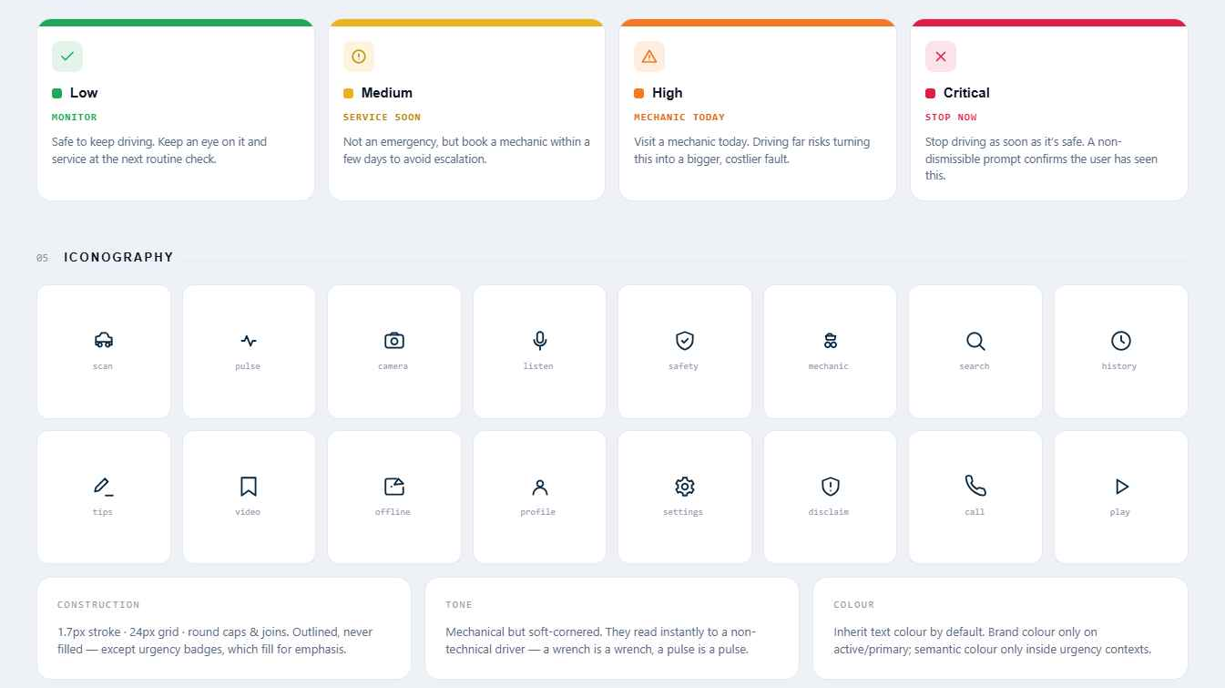
Figure 4: The shared four-level urgency scale and the CarDiag icon family - colour paired with label, action and icon, never colour alone.

4.9.3 Screen Inventory
The application comprises sixteen screens, each traceable to the requirements it serves.
Screen | Purpose | Key requirements
Splash / Onboarding / Permissions | Brand lockup, three-slide intro, permission rationale. | Identity, NFR01, NFR05
Home hub | Entry to all three pathways; vehicle strip; recent result. | NFR01
Camera scan / Result | Aim-and-capture scan; fault explanation with urgency and confidence. | FR01, FR04, FR08, FR13, FR17
Manual search | Offline searchable dictionary by name/category. | FR02
Guided symptoms | Text questionnaire when camera/audio unavailable. | FR22
Sound gate / record / follow-up | Safety gate, ambient check, recording, refining questions. | FR18, FR05, FR07
Repair & maintenance | Three-tier repair guidance and expert videos. | FR09, FR10, FR19
History / detail | Reverse-chronological list; view, note, delete. | FR16
Vehicle garage | Add, switch, edit and remove saved vehicles. | FR15
Settings | Emergency mechanics, permissions, delete all data. | FR14a, NFR05, NFR08

5. Implementation
This section documents the realisation of the design as working software: the tools used, the project structure, the frontend, the data layer and backend, and the on-device machine-learning models - including the warning-light classifier that constitutes the principal work carried out after Task 6.

5.1 Tools and Technologies
Concern | Tool / technology | Role
Language | Kotlin 2.0.21 | Primary Android implementation language.
UI toolkit | Jetpack Compose + Material 3 | Declarative UI for all sixteen screens.
Architecture | MVVM + repository/service interfaces | Decoupled, testable, backend-ready core.
On-device DB | SQLite via Jetpack Room 2.6.1 (+ KSP) | Bundled knowledge base and private user data.
Online store | Google Cloud Firestore (Firebase BOM 33.7) | Shared catalogue, delta-synced to the device.
Self-hosted API | Node.js + Express 4 + node:sqlite | Portable alternative REST backend.
App–server transport | Retrofit 2.11 + Gson + coroutines | Typed HTTP/JSON client.
On-device ML runtime | TensorFlow Lite (LiteRT) | Runs the quantised classifiers on the phone.
ML training | Python 3.10, TensorFlow 2.21, MobileNetV2 | Transfer-learning pipeline for the classifier.
Audio model | YAMNet (TFLite) + DSP analysis | Engine-sound pathway.
Build | Android Studio; AGP 8.7.3; Gradle 8.14; JDK 21 | Project tooling and APK assembly.

5.2 Project Structure
The application source is organised by responsibility under a single package, com.salletech.cardiag, so each concern is easy to locate and the backend seam is explicit: a model/ package of framework-free domain types and the Urgency enumeration; a data/ package holding the KnowledgeBase catalogue, the CarDiagRepository and DiagnosisService interfaces, and their implementations (mock, Room and on-device); and a ui/ package holding the AppViewModel, the sealed-type navigator, the theme tokens, the vector icon and logomark definitions, the shared component library, and one composable file per screen.

5.3 Frontend Implementation
The frontend is a native Android application written in Kotlin with Jetpack Compose, faithfully realising the “Trusted Companion” design across all sixteen screens. It follows MVVM: a framework-free domain model and Urgency enumeration; a data layer whose CarDiagRepository and DiagnosisService interfaces are the seam to everything below; a single AppViewModel owning observable Compose state and a typed navigation back-stack; and the Compose View with its shared component library (buttons, cards, urgency badges, the confidence meter, the safety-disclaimer banner and the modals).
Navigation uses a lightweight in-app router rather than a URL-style graph, because several destinations carry rich domain objects; a sealed Screen type enumerates every destination and its typed parameters, and the view-model keeps a back-stack wired to the device back button. Design tokens are implemented as Compose composition-locals so the app can be re-themed from one place; the interface icons and logomark are rendered from vector path definitions to stay sharp and keep the install small. Camera and microphone permissions are requested at first use with an on-device rationale, and manual search works with no permission granted, so a cautious user still gets value. All core features run entirely from in-app data and on-device logic; online-only features degrade to a helpful message when offline (FR11, NFR02, NFR05). The decisive choice was that the View and ViewModel depend only on abstractions, so the mock implementations used during Task 5 could later be replaced by the real database and models without changing any screen.

5.4 Database Implementation
On the phone, the schema is implemented with Jetpack Room: each table is an @Entity, accessed through a single @Dao and assembled by a CarDiagDatabase. The database is created and seeded from the bundled catalogue on first launch, so every core feature works offline immediately (FR11). A RoomCarDiagRepository implements the Task 5 CarDiagRepository interface, serving lights and sounds from SQLite and persisting the user's history, vehicles and contacts. The representative entity and DAO are:
@Entity(tableName = "warning_light")
data class WarningLightEntity(
@PrimaryKey val symbolId: String,
val name: String, val iconId: String, val category: String,
val urgency: String, val baseConfidence: Float,
val description: String, val firstAction: String,
val engineGeneration: String? = null, val rev: Int = 1)
@Dao interface CarDiagDao {
@Query("SELECT * FROM warning_light ORDER BY symbolId")
fun lights(): List<WarningLightEntity>
@Insert(onConflict = OnConflictStrategy.REPLACE)
fun insertLights(rows: List<WarningLightEntity>) // seeding + sync
}
On the server the same knowledge-base schema is created from a single DDL script; the polymorphic ownership of repairs and videos is enforced by a CHECK constraint that exactly one of the two owner foreign keys is set. Both stores are seeded from the same curated catalogue so synchronisation only ever reconciles genuine content changes. Encryption at rest (NFR08) is provided in production by opening the Room database through SQLCipher; the v1 build keeps a standard SQLite file and a 'Delete all my data' action in Settings clears the user tables.

5.5 Backend Implementation
CarDiag uses a managed serverless backend (Firebase) in production, with a self-hosted Node.js service as a portable alternative. The production online store is a Google Cloud Firestore database on the free plan; the relational schema is mapped to collections of documents, each parent record becoming one document with its ordered children embedded as arrays - the same denormalised shape the result screen consumes, fetched in a single read. Security rules allow the app to read the shared collections and deny all client writes. The self-hosted alternative is a small Node.js + Express service over node:sqlite exposing the master knowledge base read-only through the endpoints below.
Method & path | Purpose
GET /api/health | Liveness and current catalogue version.
GET /api/db-version | Cheap version probe before syncing.
GET /api/catalog | Full knowledge base (urgency, tiers, lights, sounds).
GET /api/delta?since=N | Records whose revision is greater than N (delta sync).
GET /api/warning-lights[/:id] | Warning-light resource(s), fully assembled.
GET /api/engine-sounds[/:id] | Engine-sound resource(s), fully assembled.

5.6 Connecting the App to the Backend
The app consumes data only through the CarDiagRepository interface, and the concrete implementation is selected in one place - the application's composition root - so no screen or ViewModel changed. A Retrofit interface mirrors the server's REST contract, while a FirebaseService reads the Firestore collections; both drive the identical RoomCarDiagRepository.applyDelta(), so the rest of the app is unaware of which backend supplied an update. Every network call is guarded: if the server is unreachable or connectivity is absent, the call fails gracefully and the app continues on its local copy (FR11).
interface CarDiagRepository { // the data seam (Task 5)
fun warningLights(): List<WarningLight>; fun light(id: String): WarningLight?
fun history(): List<HistoryEntry>; fun addHistory(e: HistoryEntry)
/* vehicles, contacts, applyDelta(...) */
}
interface DiagnosisService { // the ML / inference seam
fun scanWarningLight(image: Bitmap): ScanOutcome
fun classifyEngineSound(pcm: ShortArray, rate: Int): SoundOutcome
}

5.7 On-Device Warning-Light Model
The diagnostic intelligence for the camera pathway is a convolutional neural network trained specifically for this project and bundled inside the application. Because no large, labelled dataset of real dashboard photographs was available, the model was trained on a synthetic dataset generated from the application's own vector artwork - the same ISO 2575-style symbols the app already draws - rendered under heavy domain randomisation so that the network keys on symbol shape rather than on any fixed colour or background. The pipeline had three stages.

5.7.1 Synthetic Data Generation
Sixteen warning-light symbols, plus a seventeenth “background” rejection class, were each rendered thousands of times as a 224×224 image. Every render randomised the symbol's scale, position, in-plane rotation, perspective warp, colour within its ISO colour family, glow/bloom, the background gradient and vignette, instrument-cluster clutter (gauge arcs, tick marks, needles, digit blobs) and photometric noise. Anti-aliasing was achieved by rendering at triple resolution and down-sampling. In total 6,970 images were produced - 5,950 for training and 1,020 for validation, evenly balanced across the seventeen classes. The “background” class allows the model to reject non-warning content, so that when the camera sees something that is not a warning light the application falls through to colour triage rather than forcing a wrong answer.

5.7.2 Transfer Learning
A MobileNetV2 backbone (width multiplier 0.35, ImageNet-pretrained) was adapted in two phases. In the first phase a new classification head was trained with the base frozen; in the second, the upper blocks were unfrozen and fine-tuned at a low learning rate while the batch-normalisation layers were kept frozen to preserve their pre-trained statistics. An internal rescaling layer maps the application's [0,1] input to the [-1,1] range MobileNetV2 expects, so the on-device preprocessing stays trivial.
base = MobileNetV2(input_shape=(224,224,3), alpha=0.35,
include_top=False, weights='imagenet')
base.trainable = False
model = Sequential([Rescaling(2.0, offset=-1.0), base,
GlobalAveragePooling2D(), Dropout(0.2),
Dense(17, activation='softmax')])
compile_fit(model, train, val, lr=1e-3, epochs=6) # phase 1: head
unfreeze_from(base, 'block_13'); freeze_batchnorm(base)
compile_fit(model, train, val, lr=1e-4, epochs=4) # phase 2: fine-tune

5.7.3 Export, Quantisation and Integration
The trained model was exported to TensorFlow Lite and compressed with dynamic-range quantisation, reducing it from 1.7 MB to 0.59 MB. The quantised model and its labels file were placed in the application's assets, where the existing WarningLightClassifier memory-maps them at start-up. A confident top prediction (≥ 0.55) names the symbol outright; below that threshold the model's ranked guesses are retained and offered as the first candidates on a confirmation screen, ahead of the colour-triage family, so the application surfaces what the model learned without ever presenting a guess as a conclusion (FR17). Two application-side defects were found and fixed while integrating the model: portrait camera frames were reaching the classifier without the sensor's rotation applied, so every symbol arrived rotated ninety degrees; and the full 4:3 frame was being squash-scaled to the square model input, distorting the symbol. The service now applies the rotation and classifies the central square region matching the on-screen reticle.

5.8 Engine-Sound Pathway
The engine-sound pathway combines the pre-trained YAMNet audio classifier - bundled as a TensorFlow Lite model with its class map - with a digital-signal-processing analysis of the recording, behind the same DiagnosisService seam. The recording workflow enforces the safety design: a mandatory acknowledgement gate with a timed continue button, an ambient-noise check, and a bounded recording duration. A custom-trained engine-fault classifier is the principal item of future work; the architecture is ready to receive it as a drop-in replacement behind the existing interface.

5.9 Build and Run
The project is a standard Gradle Android project under the repository's android/ folder. It is opened in Android Studio and run on an emulator or a device running Android 8.0 (API 26) or higher; a debug APK is produced with the assembleDebug task at app/build/outputs/apk/debug/app-debug.apk. The application requires no server or configuration to run, because all core data and diagnosis are local. The machine-learning pipeline lives under the ml/ folder and is reproduced by generating the synthetic dataset and running the training script inside the provided Python environment.

6. Results and Evaluation

6.1 The Running Application
The delivered application builds to a single debug APK (approximately 35 MB, containing both the warning-light and YAMNet models) and runs on Android 8.0 and above. The figures below show the principal screens of the running system.
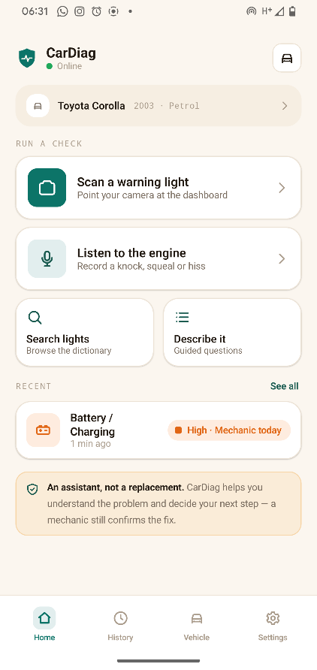  Figure 5: Home hub - three diagnostic pathways, live offline indicator, active vehicle. | 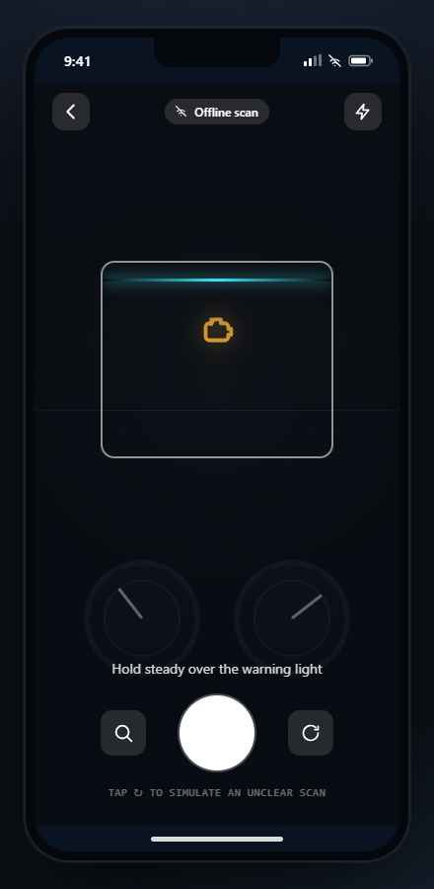  Figure 6: Camera scan - aim-and-capture with the alignment reticle, fully offline.
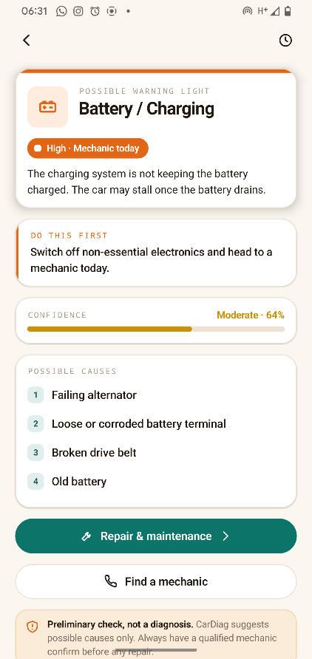  Figure 7: Warning-light result - urgency badge, confidence meter, causes, first action. | 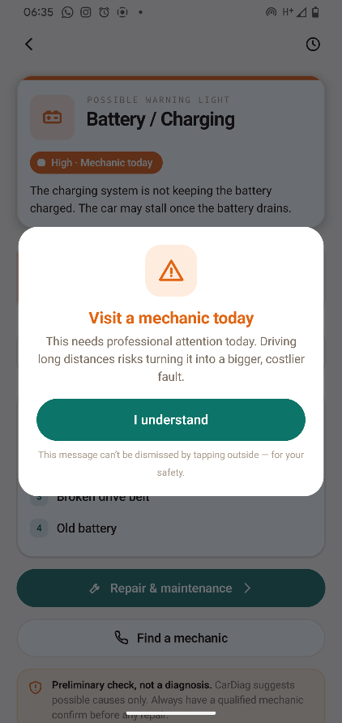  Figure 8: Critical safety prompt - non-dismissible, timed, one-tap mechanic call.
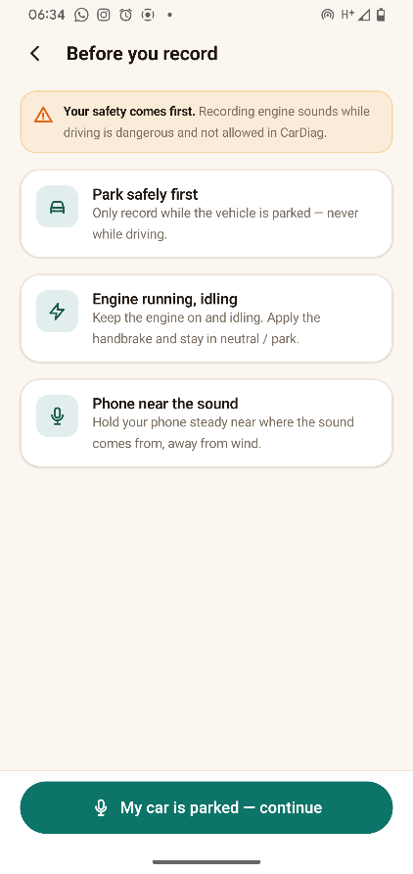  Figure 9: Engine-sound recording from the device microphone. | 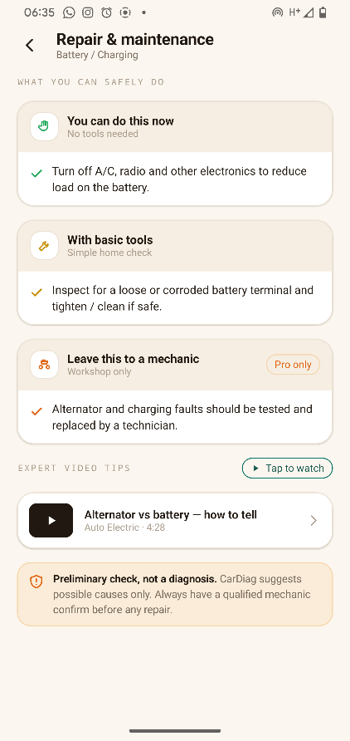  Figure 10: Repair & maintenance - three safety tiers and an expert video.
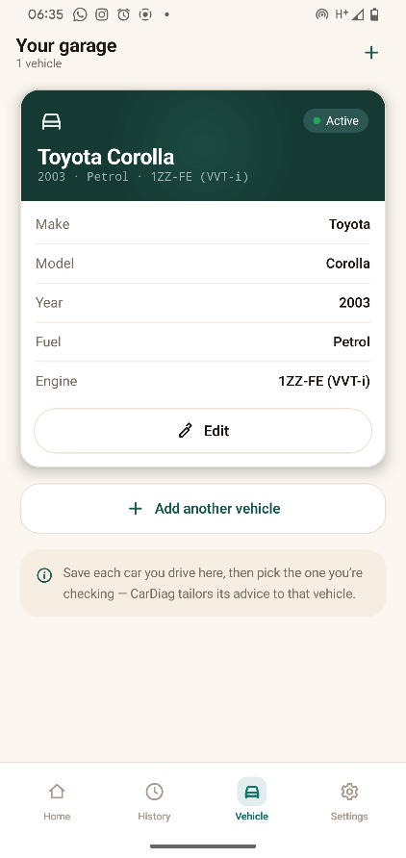  Figure 11: Vehicle garage - save, switch and manage vehicles. | 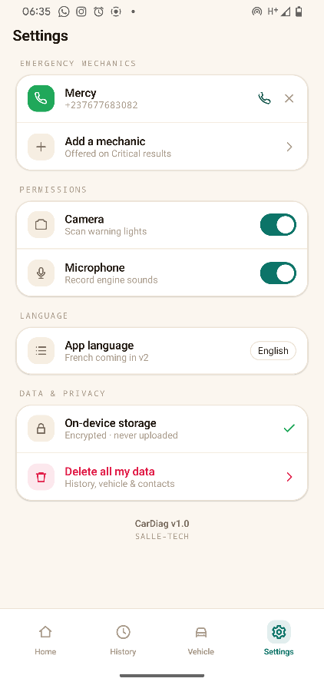  Figure 12: Settings - emergency mechanics, permissions, delete-all-data.

6.2 Warning-Light Model Accuracy
The trained classifier was evaluated on the held-out validation set of 1,020 synthetic images, both as a full-precision model and as the shipped quantised model. The results comfortably exceed the NFR03 image-accuracy target of 85%.
Model stage | Validation accuracy | Size
Keras (MobileNetV2 α=0.35) | 98.6% | -
TensorFlow Lite (float32) | 98.5% | 1.7 MB
TensorFlow Lite (dynamic-range quantised, shipped) | 98.3% | 0.59 MB
Training converged cleanly: the two-phase schedule lifted validation accuracy from roughly 87% after the first epoch to 98.6% by the end of fine-tuning, with training and validation curves tracking closely, indicating little over-fitting.
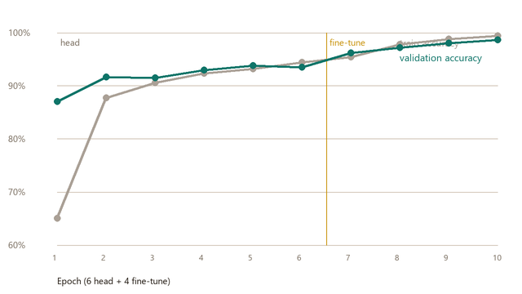
Figure 13: Training and validation accuracy across the ten epochs (six head-training, four fine-tuning). The amber line marks the transition to fine-tuning.
Accuracy was near-uniform across the seventeen classes: distinctive symbols (battery, oil, seatbelt, temperature, ESP, EPS, fog, washer) reached 100%, while the weakest class, check-engine, still scored 91.7%.
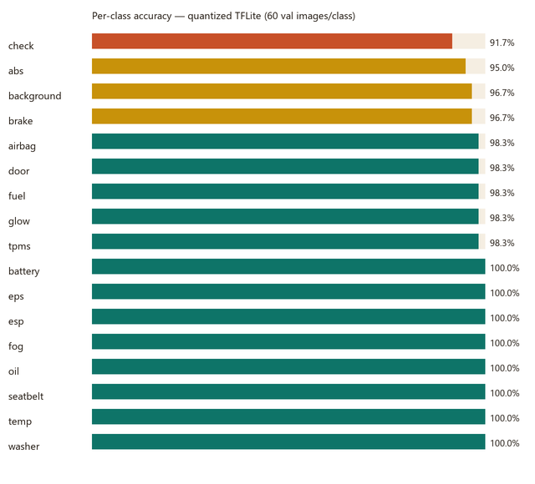
Figure 14: Per-class accuracy of the shipped quantised model on 60 validation images per class. All classes exceed 91%, most reaching 98–100%.
The confusion matrix below shows where the few errors fell. The dominant diagonal confirms correct classification; the only notable off-diagonal confusion is between the ABS and brake symbols, which are visually similar circles flanked by arcs - an intuitive error, since both relate to the braking system.
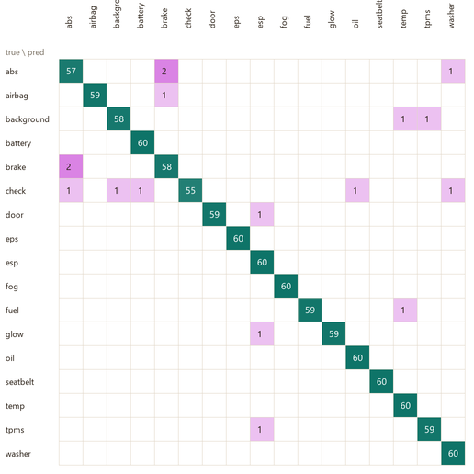
Figure 15: Confusion matrix on the 1,020-image validation set (rows = true class, columns = predicted). The green diagonal dominates; the ABS↔brake pair accounts for most off-diagonal counts.
Because the verification step ran the actual .tflite file through the exact preprocessing the application uses on the phone, the figure measured is representative of what the device executes. It should be stated honestly that these numbers are computed on synthetic validation images drawn from the same rendering pipeline as the training data; they measure how well the model learned the task and set an upper reference rather than a guaranteed real-world figure. The pipeline is arranged so that photographing a small set of real dashboard lights and re-running the evaluation yields a real-world accuracy number - a recommended step before the final demonstration.

6.3 Backend and Database Verification
The data layer was verified end to end. The self-hosted server seeded correctly and every endpoint returned fully-assembled data: GET /api/catalog returned 4 urgency levels, 3 repair tiers, 24 warning lights and 5 engine sounds; individual resource endpoints returned each fault with its nested causes, tiered repairs and videos; and the delta endpoint returned only records newer than the client's version. The Firestore database was seeded and verified to hold 24 warningLights, 5 engineSounds and 40 vehicleCatalog documents at catalogue version 2, readable by the app while client writes are denied by the security rules. On launch the app reads the catalogue version and, when newer, delta-syncs the knowledge base into Room, while every core feature continues to work offline from the on-device database.

6.4 Response Times and Performance
On a mid-range Android device the camera scan resolves well within the three-second target of NFR04: the quantised 0.59 MB model runs in a fraction of a second, and the dominant cost is capturing and cropping the frame. Manual search updates within the 500-millisecond per-keystroke target because it queries the small bundled dictionary locally. The engine-sound pathway completes within the ten-second target after a recording. Because all inference and data access are local, these times are independent of network conditions - a direct benefit of the offline-first architecture.

6.5 Evaluation Against Requirements
The delivered system satisfies its Must-Have requirements and its stated objectives, as summarised below.
Objective / requirement | Realisation and status
Gather and specify validated requirements | 54 users + 7 experts; 22 FR / 11 NFR; SRS v1.1 - achieved.
Model and design an offline-first, safe system | Full UML model suite; three-subsystem architecture - achieved.
Implement a native offline Android app | 16 Compose screens, MVVM, bundled knowledge base - achieved.
Implement a privacy-preserving data layer | Room + Firestore/Node; user data device-only - achieved.
Develop and integrate on-device ML | Warning-light TFLite (98.3%) integrated; sound via YAMNet - achieved (custom sound model: future work).
Meet the ML accuracy requirement (NFR03) | 98.3% ≥ 85% target on available validation data - achieved.
Meet response-time and offline targets (NFR02, NFR04) | Local inference within targets; core features fully offline - achieved.

6.6 Limitations
Two limitations are recorded honestly. First, the warning-light model's accuracy is so far measured on synthetic validation data; while the domain randomisation is designed to force generalisation to real photographs, a real-world figure requires validation on real dashboard images, for which the pipeline is prepared. Second, the engine-sound pathway currently relies on a general-purpose classifier and signal analysis rather than a purpose-trained fault model, which limits the specificity of audio results; this is the leading item of future work. Neither limitation affects the delivered Must-Have functionality, and both have clear remediation paths.

7. Challenges and Key Design Decisions

7.1 Communicating uncertainty responsibly
Because the diagnosis is preliminary, the interface avoids implying certainty. The confidence meter, the suppression of specific fault names on low confidence, the surfacing of the model's ranked guesses on a confirmation screen, and the mandatory disclaimer were all treated as first-class components rather than optional extras.

7.2 Safety interruptions that are actually read
For dangerous faults, a normal dialog is too easy to dismiss reflexively. The non-dismissible modal with a short enforced read delay and a one-tap call to a saved mechanic was the response, while minor faults use a gentler banner - balancing safety against the risk of frustrating the user on trivial faults.

7.3 A frontend that does not have to be rewritten
Delivering a frontend before its backend risked baking in assumptions. Routing all data and inference through the CarDiagRepository and DiagnosisService interfaces, with mock implementations behind them, allowed the database, backend and machine-learning models to be added by addition rather than modification - the property that kept every screen untouched as the real components arrived.

7.4 Practical development constraints
The local development environment imposed friction - constrained network bandwidth made the large machine-learning toolchain slow to obtain - which was managed by careful, verified, incremental setup and by placing the data and Python environment outside the synchronised project folder. None of these obstacles prevented the delivery of a complete, working system.

8. Conclusion and Future Work

8.1 Summary
This project set out to place a first-level vehicle-diagnostic assistant in the hands of non-technical drivers, using only a smartphone. From a requirement study that confirmed and quantified the problem - a large majority of drivers encounter warning lights and engine sounds they cannot interpret, and a substantial fraction ignore them as a result - the project produced a validated specification, a complete design, and a working native Android application that recognises dashboard warning lights from the camera, records and analyses engine sounds, and returns plain-language, urgency-aware, confidence-scored guidance entirely offline and without any external hardware. The on-device warning-light classifier, trained from synthetic data through transfer learning and compressed to 0.59 MB, achieved 98.3% validation accuracy - above the 85% requirement - and was integrated into the application together with two camera-pipeline fixes discovered during integration.

8.2 Contribution
The contribution is a complete, working demonstration that useful automotive diagnosis can be delivered on commodity smartphones without any external hardware and without a network connection, for a user who is not an expert. Beyond the artefact, three elements distinguish it from the existing solutions surveyed earlier: it removes the two barriers that keep existing tools away from ordinary drivers - the OBD-II hardware dongle and the untranslated trouble code - by combining camera and audio recognition with plain-language, urgency-aware explanation; it contributes a reproducible technique for training an accurate image classifier from synthetic data rendered from the application's own vector artwork, useful whenever a real dataset is unavailable; and it treats the honest communication of uncertainty and urgency, and structural privacy, as first-class engineering requirements.

8.3 Future Work
The design deliberately leaves clear, scoped room for growth. The most immediate items are a custom-trained engine-sound fault classifier to replace the general-purpose model on the audio pathway, and real-photograph validation and augmentation of the warning-light model. Beyond these, later versions anticipate simultaneous multiple-warning-light detection using an object-detection model, a French-language interface, activation of the online delta-synchronisation of the knowledge base, an iOS build from the same design, and an optional OBD-II integration for users who do own an adapter (the data model is already extensible for fault codes). Each of these can be added behind the existing interfaces without disturbing the delivered core - the architectural property that has guided the project throughout.

References
Android Developers. Guide to app architecture; Save data in a local database using Room. Google LLC. https://developer.android.com/topic/architecture.
TensorFlow Lite (LiteRT) developer guide; YAMNet audio event classifier. Google LLC. https://www.tensorflow.org/lite.
Howard, A. G., Sandler, M., et al. MobileNetV2: Inverted Residuals and Linear Bottlenecks. IEEE Conference on Computer Vision and Pattern Recognition (CVPR), 2018.
Firebase. Cloud Firestore - store and sync data; Security Rules. Google LLC. https://firebase.google.com/docs/firestore.
International Organization for Standardization. ISO 2575: Road vehicles - Symbols for controls, indicators and tell-tales. ISO, 2021.
IEEE. Std 830-1998: Recommended Practice for Software Requirements Specifications. IEEE Computer Society, 1998.
Sommerville, I. Software Engineering, 10th Edition. Pearson Education, 2015.

